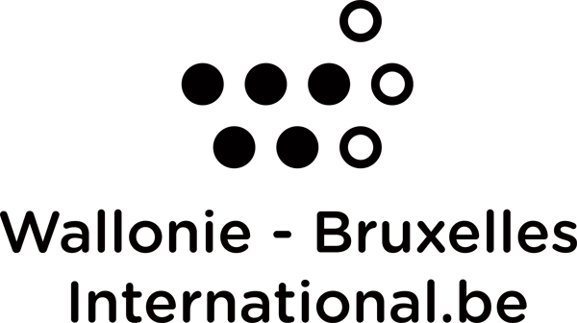

IN WBI Excellence Grant Programme

Renewal application form

This document is to be sent by email to bourses@wbi.be by the 1st of May at the latest, accompanied by a letter (in free format) written by the professor or the expert supervising your research. This letter should reflect the progress of the work and confirm the need to extend funding. A reply will be sent to you by the 15th of July at the latest.

Wallonia-Brussels International
International Scholarship Department, coordination of academic and cultural liaison officers (ALAC)

Updated on november 2021

To be completed and returned by the Candidate

LAST NAME :
First name :
Country :
Host institution :
Research title :
Renewal requested for the academic year ....- ....

Progress of work (up to 3000 characters in length) :

